Exam1

Beatrice Severance, Zachary Noel

2023-03-02

## R Markdown

### Question 4

#load in and view dataset  
data("PlantGrowth")  
head(PlantGrowth)

## weight group  
## 1 4.17 ctrl  
## 2 5.58 ctrl  
## 3 5.18 ctrl  
## 4 6.11 ctrl  
## 5 4.50 ctrl  
## 6 4.61 ctrl

#load dependencies  
library(ggplot2)

## Warning: package 'ggplot2' was built under R version 4.1.3

#layering  
ggplot(PlantGrowth, aes(x = group, y = weight)) +  
 geom_point(aes(color = group))

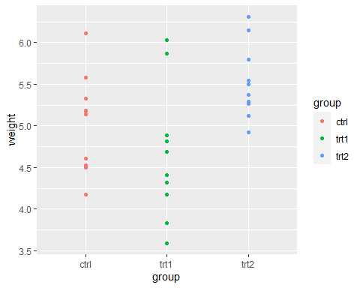

#scales  
ggplot(PlantGrowth, aes(x = group, y = weight)) +  
 geom_point(aes(color = group)) +  
 theme_classic() +  
 facet_wrap(~group, scales = "free")

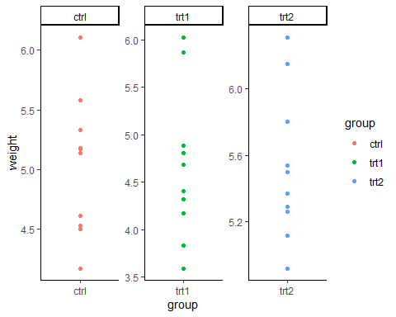

#theme  
ggplot(PlantGrowth, aes(x = group, y = weight)) +  
 geom_point(aes(color = group)) +  
 theme_classic()

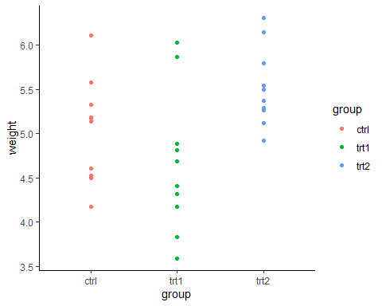

ggplot(PlantGrowth, aes(x = group, y = weight)) +  
 geom_point(aes(color = group)) +  
 theme_bw()

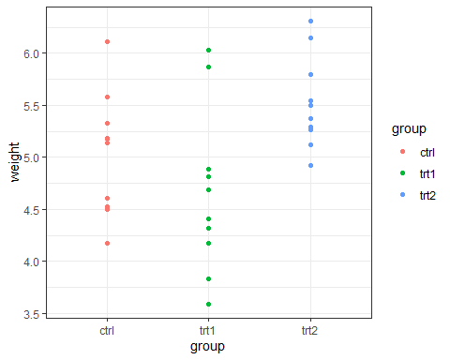

#facets  
ggplot(PlantGrowth, aes(x = group, y = weight)) +  
 geom_point(aes(color = group)) +  
 theme_classic() +  
 facet_wrap(~group, scales = "free_x")

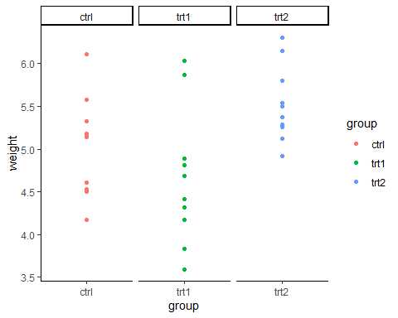

### Question 5

#load in and view dataset  
data("ToothGrowth")  
head(ToothGrowth)

## len supp dose  
## 1 4.2 VC 0.5  
## 2 11.5 VC 0.5  
## 3 7.3 VC 0.5  
## 4 5.8 VC 0.5  
## 5 6.4 VC 0.5  
## 6 10.0 VC 0.5

#two ways to subset supp = VC  
tooth.supp.eq.vc <- ToothGrowth[ToothGrowth$supp == "VC",]  
tooth.supp.eq.vc1 <- subset(ToothGrowth, supp == "VC")  
  
#two ways to subset supp = VC and dose = 0.5  
tooth.suppvc.dose05 <- ToothGrowth[ToothGrowth$supp == "VC" &   
 ToothGrowth$dose == 0.5,]  
tooth.suppvc.dose05.1 <- subset(ToothGrowth, supp == "VC" & dose == 0.5)  
  
#two ways to include len values when supp = VC and dose = 0.5  
tooth.supp.len <- ToothGrowth[ToothGrowth$len %in% ToothGrowth$supp == "VC" &   
 ToothGrowth$dose == 0.5,]  
tooth.supp.len1 <- subset(ToothGrowth, )